DOI: https://doi.org/10.52651/sam.j.xxxx.x



THE BRIEF AND MAIN TITLE

(Times New Roman, capital letters, bold, 12 pt, aligned to the center, line spacing 1)
1x blank line, 12 pt

Name SURNAME

(Times New Roman, normal letters, 10 pt, aligned to the center, line spacing 1)
1 x blank line, 10 pt
Abstract: The abstract of the paper brings brief information about the contents of the paper - topic, problem, solved, objective, main conclusions and benefit. Text in English, Times New Roman, normal letters, 9 pt, extend 3 – 7 lines, line spacing 1. The abstract does not replace the introduction of the article!
1 x blank line, 9 pt
Keywords: 5 – 6 keywords in English, Times New Roman, normal letters, 9 pt, separated by semicolons, line spacing 1.
2 x blank line, 9 pt

INTRODUCTION

In the introduction, you should characterize the objectives, methods used, sources, assumptions, research questions, and other information, which you want to include in your article.
Upper and lower margins must be set to 25 mm, left and right margins to 25 mm. The distance between the header/footer and the page margins must be 12,5 mm.
The article must be written in 2 columns format with a 75 mm column width and 10 mm empty space separating the columns.
The article text must be written using Times New Roman, normal letters, 10 pt, line spacing 1,
The first line of each paragraph must be shifted
5 mm to the right.
Length of the article should not exceed 6 - 8 pages in defined format.

TITLE OF A SECTION

Mathematial equations in the text must be written using the equation editor. They must be numbered. Numbers are to be enclosed in parentheses
and aligned to the right margin of a column.

(1)

(2)

2.1 Title of a subsection

Figures, graphs and tables must be included in the text and numbered and must contain description. Figures must be identified as Fig. 1 followed by the figure description – Times New Roman, 9 pt normal letters. Graphs must be identified as Graph 1 followed by the graph description – Times New Roman, 9 pt normal letters. Tables must be identified as Tab. 1., followed by the table description – Time New Roman, 9 pt normal letters.
Photographs for publication must be in black-white (not in color) of excelent quality with good contrast.
It is always necessary to cite the source!

Tab. 1 Title of the Table (Times New Roman, 9 pt,
left- aligned)
Carcinogenic risk for people, CR | 5.62·10⁻⁰⁵
Non-carcinogenic risk for people, HI | 0.433

Source: author.

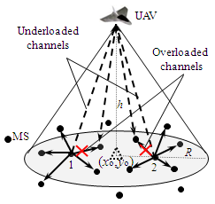
Fig. 1 Title of the Figure (Times New Roman, 9 pt, aligned to the centre)
Source: [4].

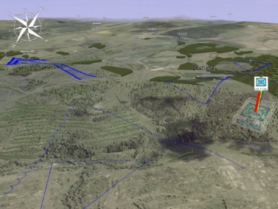
Fig. 2 Title of the Figure (Times New Roman, 9 pt, aligned to the centre)
Source: author.

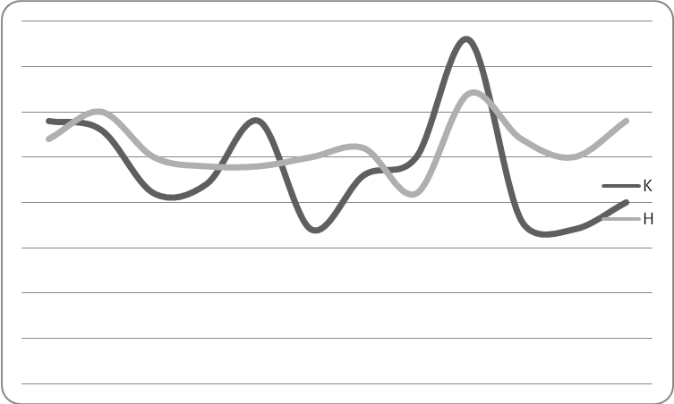
Fig. 3 Title of the Figure (Times New Roman, 9 pt, aligned to the centre)
Source: author.

CONCLUSION

Conclusion should summarize your contribution, interpret results, indicate the confirmation of the hypothesis, provide answers to the research questions, sum up your recommendations.
In the case of the scientific paper, the author´s original results are required to be presented in the conclusion of the contribution.

Acknowledgement

Of your choise, write for example: The article
is an (partial) output of research project VEGA MŠ SR a SAV No. VEGA 1/0000/15 entitled… or This contribution is the result of the project VEGA (5/1234/12) Perspectives of the asdf etc.

3 x free lines, 10 pt

References

References must be fully and accurately documented, according to the norm STN ISO 690:2022-06 (01 0197) Information and documentation. Guidelines for bibliografic references and citations to information resources.
References must be quoted in the text in square brackets and listed in the order they have apear in the text (Vancouver style). Note: The Vancouver style uses the citation-sequence system, meaning that references at the end of your article are numbered in the order in which the corresponding citations appear in your text, rather than listed alphabetically by author.
If article has a DOI number, then it must be written after cite, after dots. It is necessary! DOI number must be written in format: http://doi.org/10.1007/978-3-319-24574-4_28. DOI number you can find on www.crossref.org . Author is allowed in case of internet resources to use URL shortener. Use e.g. "Internet address shortener" (https://lnk.sk/en).

[1] RYBÁR, Ladislav. 1980. Základy rétorickej komunikácie. Bratislava: Obzor. 304 s. ISBN 65-014-80.
[2] CANDRÁKOVÁ, Eva et al. 2015. Pestovanie poľných plodín. Nitra: Slovenská poľnohospodárska univerzita. 145 s. ISBN 978-80-552-1352.
[3] LUKÁŠIK, P. 2022. Analýza parametrov motorových olejov a ich optimalizácia pre mobilnú techniku. Dizertačná práca. Liptovský Mikuláš: Akadémia ozbrojených síl generála
M. R. Štefánika. p. 73 – 76.
[4] HANUSOVÁ, Jana; MILUCHOVÁ, Martina and GÁBOR, Michal. 2022. Evaluation of amino acids in meat and liver of nutria. In Journal of Central European Agriculture. (Online). Vol. 23, no. 1, pp. 24-30. Available at: https.//doi.org/10.5513/JCEA01/23.1.3420 [cit. 2022-09-25].
[5] AICHBAUER, Štefan et al. 2022. Responsible Procurement: Leading the Way to a Sustainable Tomorow. (Online). Cham. Springer International Publishing. 193 s.
ISBN 978-3-030-98639-1. Available at: https.//doi.org/10.1007/978-3-030-98640-7 [cit. 2023-04-21].
[6] Zákon NR SR č. 131/2002 Z. z. o vysokých školách a o zmene a doplnení niektorých zákonov v znení neskorších predpisov.
[6] TVRDÁ, Eva; GOSALVEZ, Jaime and AGARWAL, Ashok. 2015. Epigenetics and its role in male infertility. In Watson, Ronald R. Handbook of fertility. New York: Elsevier, pp. 411-422. ISBN 978-012800993-2.

Titles, Name SURNAME of the author
(co-authors)
Address of workplace
E-mail address

Professional CV

Along with your original contribution, please provide (including co-authors) your brief unstructured-professional CV to be published in the form of a running text in the extent max 500 characters (with spaces ) in English.
The author shall be responsible for the quality and the correct translation of the English text.
The brief professional resume should contain the following: Full name and titles of the author, Brief information on education and professional career, current workplace, professional specialisation, optionally.

